|  |  |  |  |  |  |  |  |  |
| --- | --- | --- | --- | --- | --- | --- | --- | --- |
| **MAD Project Evaluation 1 – June Intake 2022** | | | | | | | | |
| **Team Name:** | CroobyBeans | |  |  | **Batch:** | Batch 01 | | |
| Student ID | Student Name | Consistency (Out of 2) | Appropriateness and Professionalism (Out of 3) | Usage of resource manager (Out of 4) | Out of box design ideas (Out of 3) | Report (Out of 8) | Total (Out of 20) | Comments |
| IT20299552 | Rubasinghe L.M |  |  |  |  |  |  |  |
| IT20605902 | Samarasinghe S.D |  |  |  |  |  |  |
| IT20604844 | Thilakarathna W.G.T.D |  |  |  |  |  |  |
| IT20607678 | Senevirathne W.S.M.S.D |  |  |  |  |  |  |
|  |  |  |  |  |  |  |  |

Git Repository Link: <https://github.com/SDSamarasinghe/Top_Jobs_Crooby_Beans>

(If already created)

----------------------------------------------------------------------------------------------------------For Evaluators use only---------------------------------------------------------------------------------------------

Evaluator’s name:

Others:

1. **Introduction to the Project**

In the modern world everyone is undergoing busier lives than ever. People do not have time to read newspapers and random websites to search for job opportunities. And they are going to smart world day by day. To overcome this problem, we are going to create “TopJobs” android app. This will be a free job vacancy app which is mainly designed to help who are looking for a job in IT field. Also, the companies that offer jobs can find employees with required qualifications using “TopJobs” app.

Users can simply register for the app, and they can find their dream jobs in all career levels, part time jobs and internships in an easy and convenient way through this app whether you are a fresh graduate or an experienced professional. It can be used to keep an eye on the employment market even once you have found an employment. It will keep you up to date with the changing job market and never let you miss your next best career. If you are searching for a job the home page of the app will help you to find a job. If you find the jobs, you need you can contact the company and apply for the job by a simple touch of a button.

Do not close the app if you did not find the required opportunity, you can post a job request. You can market yourself by adding your educational qualifications, experience in the field and other qualifications to the job request. You can attract the world's best companies in the IT field anytime anywhere. While you are scrolling through the job vacancies, finding one and planning to apply for it later you can save it for future reference and apply when you are free. It is specifically designed to minimize misplacing your job advertisements.

If a company is seeking for an individual with the necessary skills to hire, they can post a job advertisement to find a suitable candidate from the millions of qualified job seekers all over the world. We do not mind if you are a brand-new startup or a company that has a history of more than 10 years, the app is open for everyone.

1. **Individual Contribution**

|  |  |
| --- | --- |
| IT20299552  Home Page –   * No Cruds   Edit Requested Jobs –   * Update   My Requested Jobs –   * Read   View a Posted Job –   * Read   Saved Requested Jobs –   * Create, Delete | IT20605902  Create New Jobs –   * Create   Edit Profile –   * Update   Request a Job –   * Create   View a Requested Job –   * Read |
| IT20604844  Login Page –   * Validations   Register New Users –   * Create   Update and Delete Created Jobs –   * Update, Delete   Saved Jobs –   * Read   Saved Requested Jobs –   * Read   Calculate Salary | IT20607678  Save Jobs and Delete Saved Jobs –   * Create, Delete   My Job Listing –   * Read   Requested Jobs –   * Read   Navigation Bar –   * No Cruds |

1. **A screenshot of a computer

   Description automatically generated with low confidenceUI Connection**
2. **UI – Functionalities, Crud Operations, Resource Files**

IT20299552 - Home Page, Edit Requested Jobs, My Requested Jobs, View a Posted Job, My Saved Requested Jobs

|  |
| --- |
| When the user loads the app, at first, he or she appears this page. When user comes to the home page, it displays welcome message as “Welcome to TopJobs”. Users see job vacancies and they can view more details about the job by tap on the job title or company icon. |

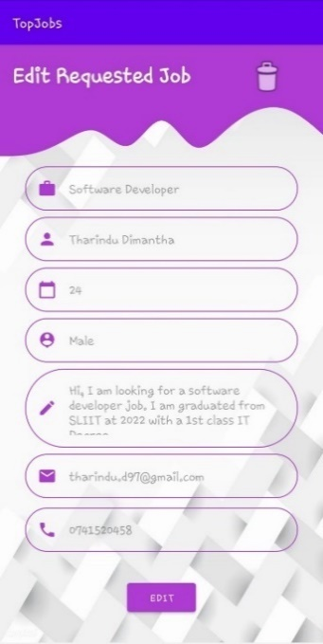

|  |
| --- |
| User can edit their job requests details by using this interface. At here users can not empty required fields. If they missed required fields app prompts error messages. |

|  |
| --- |
| Users can view their requested jobs by using this interface. |

|  |
| --- |
| User or Admin can view posted job vacancies by using this interface. Also, they can edit posted vacancies by tap on edit button.  User can see edit button for only their posted jobs for other jobs they cannot see edit button. |

|  |
| --- |
|  |

|  |
| --- |
| Users (companies) can save requested jobs to call to requesters for the career opportunities. They can delete requested jobs by using this interface. |

**Crud Operations Describe**

After loading the app anyone of the user who use our application can visible the **Homepage** of the app, when the user comes to homepage at any time homepage displays a welcome message like “Welcome to TopJobs “.

However, users can visit posted job opportunities without registration or login. Users can scroll through the job opportunities to find what are the job opportunities they want.

Also, they can **View Jobs** by taps on company icon or job title without login. **(Read)**

For all the other functionalities user must need to register to app and login.

To go to the **My Requested Jobs** Page user must login to the system, then he can tap on the navigation bar and select the My Requested Job category, then user can see what the jobs are he requested. **(Read)** and he can tap on the displaying label, then he redirects to another page and then he can see edit button, when the user taps on edit button, he redirects to **Edit Requested Job** page and now he can edit details he provided to the app when he requested a job. **(Update)** In the edit, user can not empty required fields such as Job Title, Name, Age, and Description. Also, the user cannot enter above or less than 10 digits for a phone number field and he needs to provide valid email address.

If the user fails to provide valid details the app will prompt warnings and error messages such as “Required Field”, “Invalid Input”.

Users can go to **Requested Jobs** and **save** Employees according to their company or personal requirements. Then he can access the **Saved Requested Jobs** by tapping on Saved Requested Job category in the navigation bar when he taps on it, user redirects to page and user can see what the jobs are he saved from requested jobs list. User can delete Saved Requested Jobs from the list. **(Delete)**

IT20605902 – Create new Jobs, Edit Profile, Request a job, View of Requested Job

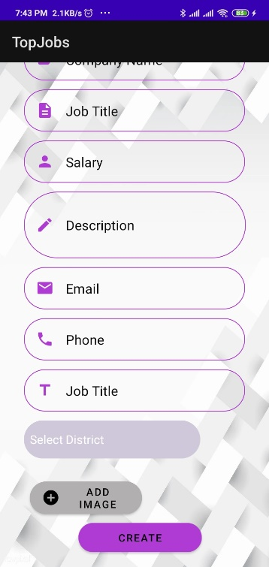

|  |
| --- |
| This is Create Job page. If registered user wants create some jobs. He/She should go to my job listing and click on create new job. |

|  |
| --- |
| Users can go their profiles through the job listing page (in the navigation menu display component call “my profile”). In this page user can choose proper image for their profile picture. This page include 8 component and user can logout from their profile using bottom icon. I’m already use some spinners to make drop down lists. If user press Edit button, it will navigate to profile update page. Then user can update their profile with changing these values. |

|  |
| --- |
| User can go to the My Requested jobs page by pressing the “My Requested Jobs” button in the navigation menu. It also same as My Job Listings page and there are job requests that users made and there is a button called “Request New” to go to the Request a job page. |

|  |
| --- |
| This page also similar like the view of posted job, it has job title, name, gender, and age of the applicant. It consists brief description of the applicant and what type of job searching. |

**Crud Operations Describe**

|  |
| --- |
| After login user can create jobs and publish it as an advertisement. User can go job listing page and click “Create new Job”. This interface has 10 components. 9 components are text and top down and other one is add image component. If user is already registered this system. User will redirect to the listing jobs. Otherwise, user will automatically redirect to the login page. User must fill all these things. **(Create).**  In the profile page user can view their details on the page and if user want change values in the profile. **(View)** He/she can press Edit button and user will be navigate to another ui. It contains similar component as previously. Now user can change values using edit text boxes and drop-down list**. (Update)**  User can go to the My Requested jobs page by pressing the “My Requested Jobs” button in the navigation menu. It also same as My Job Listings page and there are job requests that users made and there is a button called “Request New” to go to the Request a job page. In the Request job page, I have implemented some component using text box, spinners, and buttons user can request a new job after filling all these details. He/She cannot press “REQUEST” button without filling any of this fields**. (Create).**  User can go “My requested Jobs” through navigation bar. Then user can view all the requested jobs. If user want to see further details of that job, he/she can visit the view of that page click on it**. (View)** |

String resources file and Color resources file

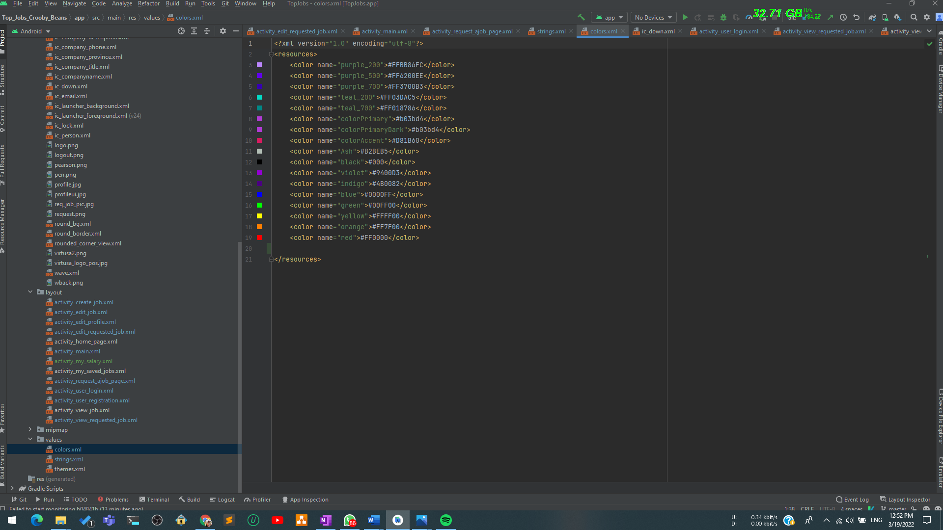

IT20604844 – User Login, User Registration, Edit and Delete Created Job, My salary, view saved joblist

1.User Login

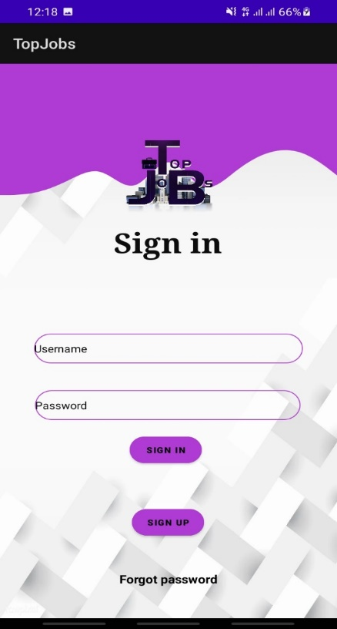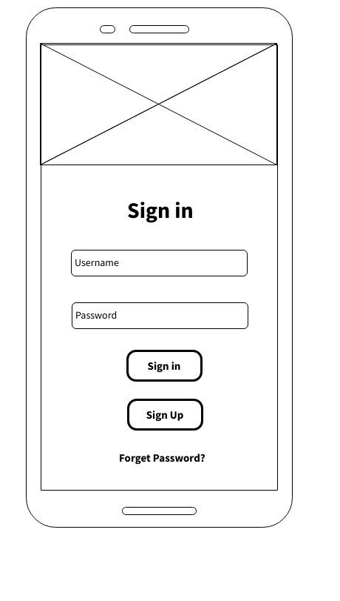

|  |
| --- |
| This is a login authentication in this app. It allows registered user to access this system and it contains login validation and if the login is successful app will display a message as “login successful”. |

2.User Registration

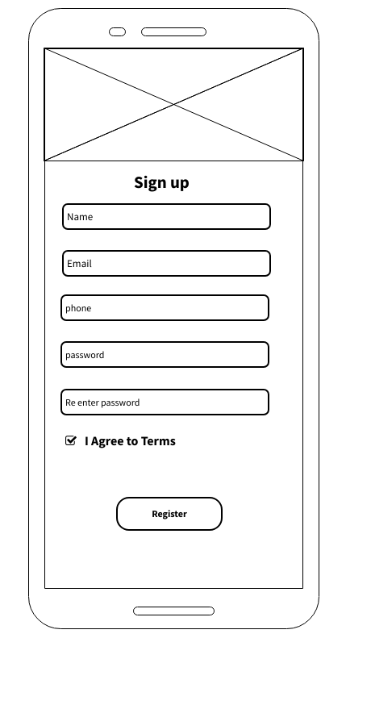 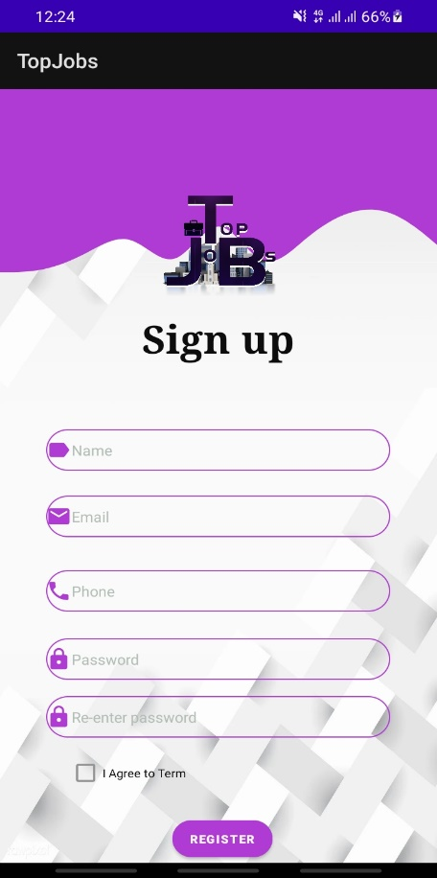

|  |
| --- |
| Sign up system that allows user to create new account to the system. It only asks for a name, email, phone and password and confirm password. This interface form contains form validation methods. Multiple accounts for the same email address are not allowed. After the registration will be done successfully app display a successful message as “Register Successfully”. |

3. Update /delete Created Jobs

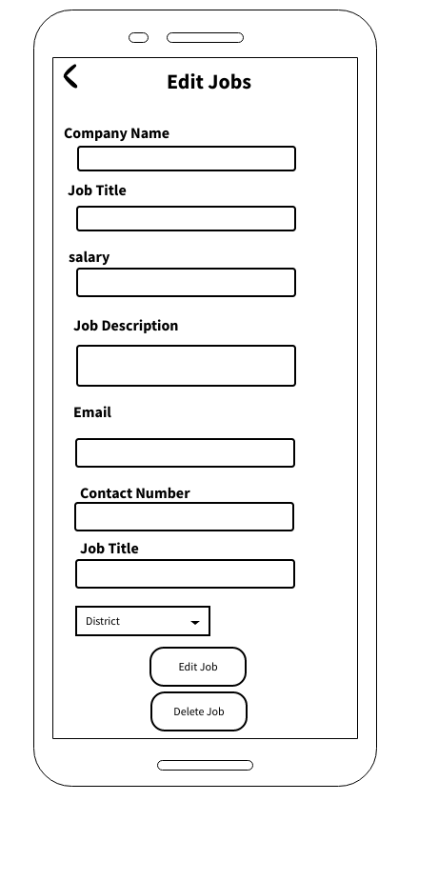 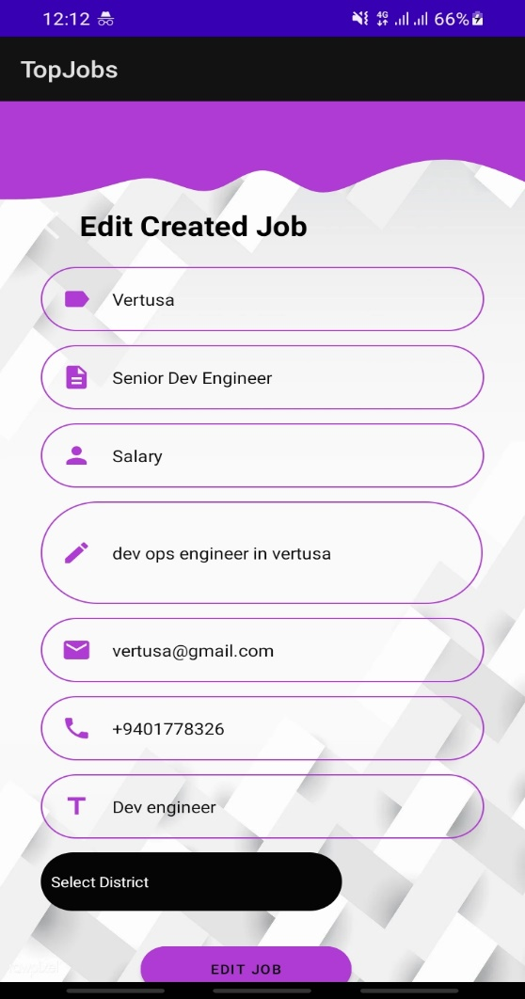 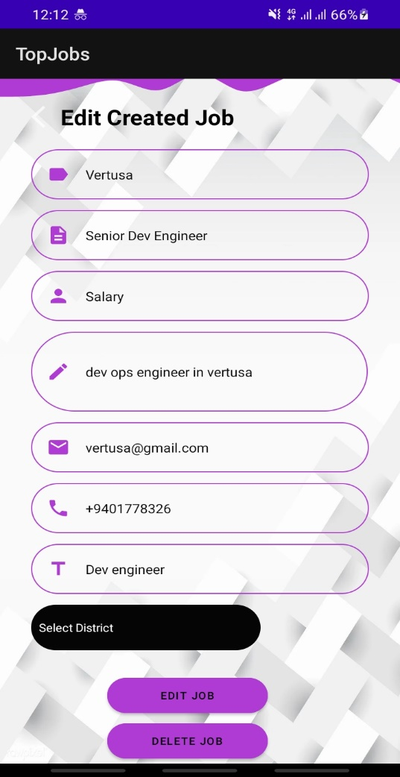

|  |
| --- |
| Job creator can change an existing job record in the system by their needed and user want to remove previous created jobs from the system delete button will lead that |

4.My Salary Calculator

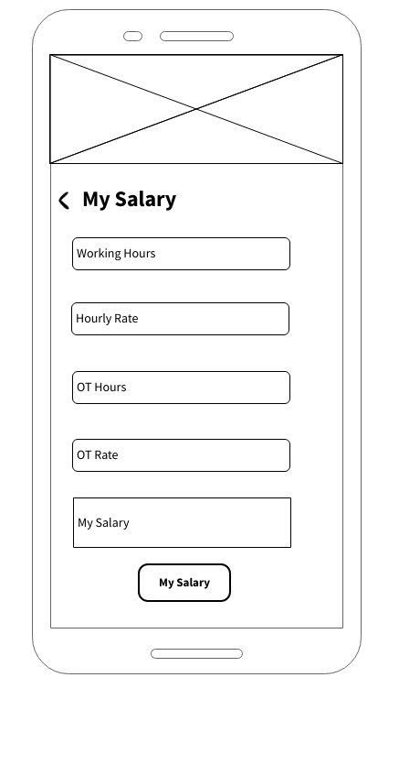 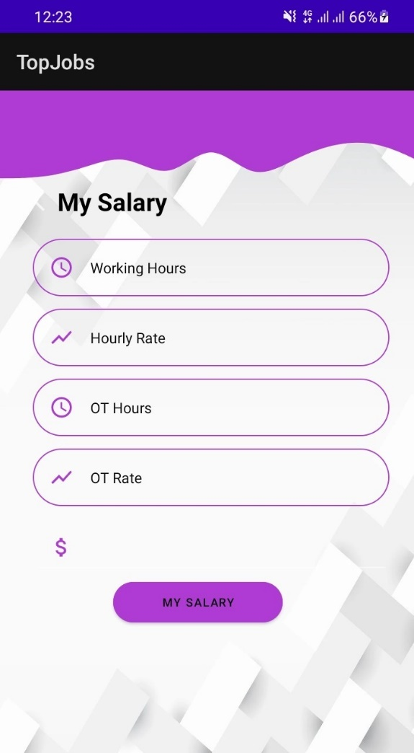

|  |
| --- |
| User can enter salary ranges offered by companies and calculate the annual or monthly salary of their dream job |

**Crud Operations Describe**

|  |
| --- |
| After the loading the application user must login to the system to access the functionalities. Then the user wants to tap on the login button in the navigation bar.  When user taps on the login button app will redirects to sign in page and user enter valid user credentials after clicks on sign in button and if the user name and password match the user authorized and granted access to the app otherwise the login attempt will be rejected. If the login is successful app will display a message as “Login Successful” and app will redirect to user select functionalities. (Login validation)  If user have not registered to the system first, he or she wants to sign up to the system. It only asks for a name, email, phone and password and confirm password. This interface form contains form validation methods. Multiple accounts for the same email address are not allowed. After the sign-up user can login to the app using his credentials**. (create)**  Job creator can edit jobs taps on edit button in edit created job page and he can edit job details he provided to app when he or she created job. **(Update)**  This interface form contains form validation methods so job creator cannot empty required fields such as “job title”, “company name” etc. If the job creator fails to provide these requirements app will provide warnings and error messages as “Require Field”, “Invalid input”.  Job creator want to remove previous created jobs from the system delete button in edit job page will lead to that. **(delete)**  User can go to the saved job page and user can read all of the data in there by using database**(read).**  Job finder can calculate salary by using “My Salary Calculator” and enter salary ranges offered by companies and calculate the salary of their dream jobs. (calculation) |

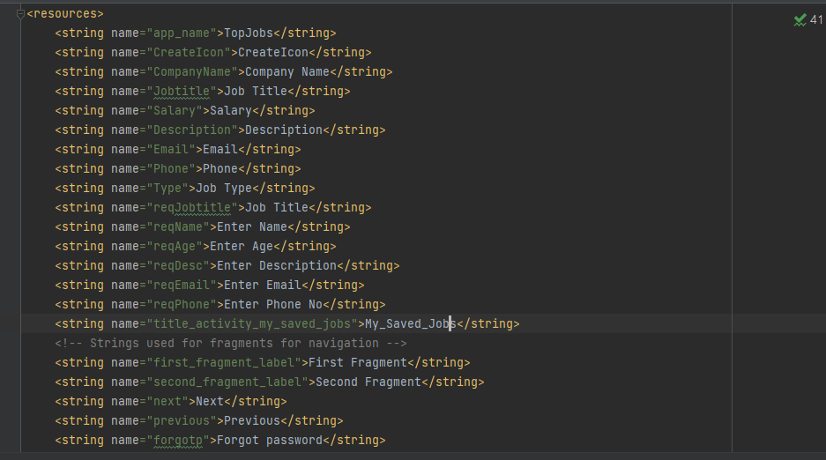

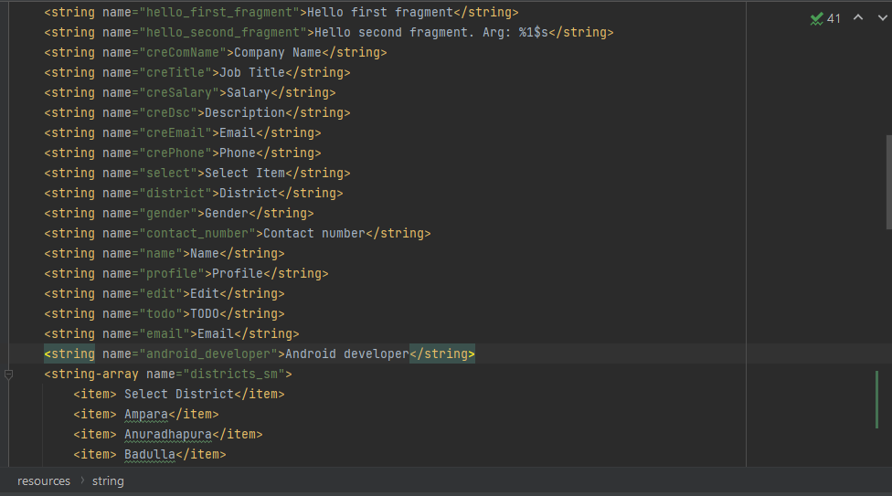

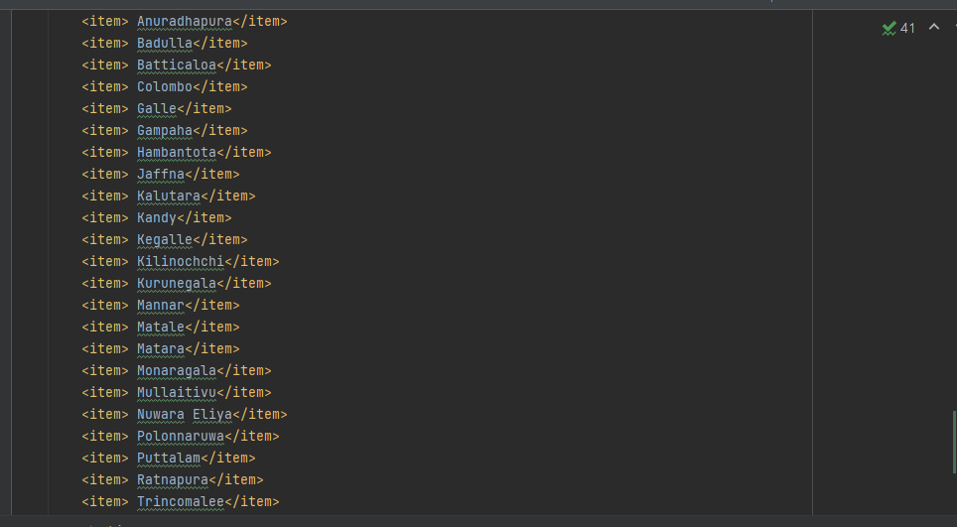

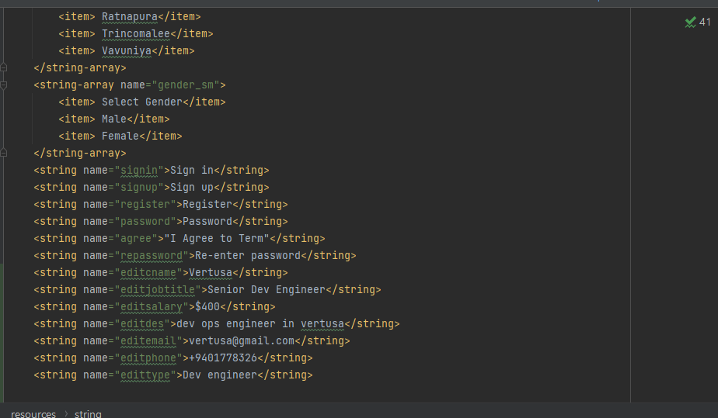

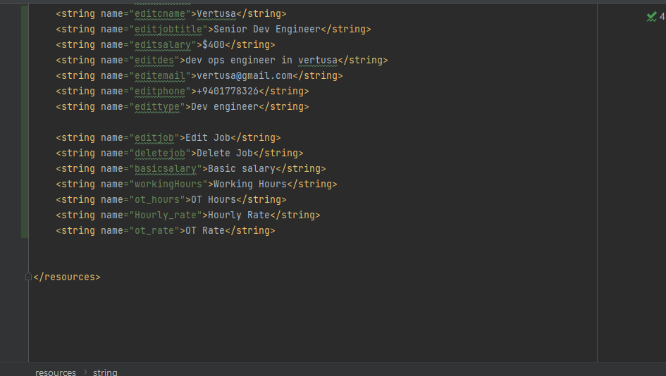

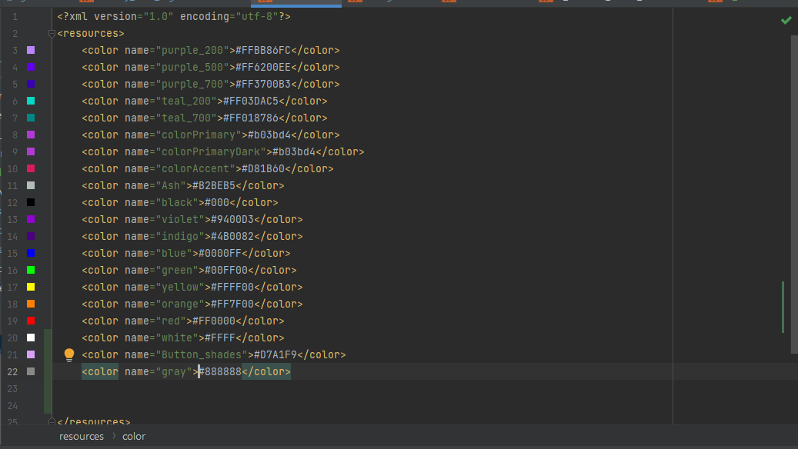

1. IT20607678 – Create Save jobs, Delete saved jobs, My job vacancies(view), requested jobs(view), ,Navigation Bar

**1)Create save jobs and Delete saved jobs**

|  |
| --- |
| After saving the jobs, the user can move to the navigation bar and click “My Saved Jobs” to view all the jobs they saved  Also saved jobs can be removed by using delete icon. |

**2)My Job Vacancies

|  |
| --- |
| User can go to the My Job Vacancies page by pressing the “My Job Vacancies” button in the navigation menu. My Job Vacancies page consists of the job advertisements that user created. User can view those ads by clicking them. There is “Create New'' button to direct Create New Job page. |

3)Requested jobs

|  |
| --- |
| Inside the menu bar by clicking Requested jobs its redirect to this page and display all the requested jobs lists for the user.  Its display details of each requested jobs separately. |

4)Navigation bar

|  |
| --- |
| Navigation bar upper part consists with logo and name of the application and there is a button for logout next to the logo.  By clicking on the profile user will redirects to profile page.  There are seven buttons consists in the menu including Home, My job vacancies, saved jobs, Requested jobs, My requested jobs, save requested jobs and calculate salary. All buttons are redirects to the relevant pages. |

**Crud Operations Describe**

After login to the application, user allows to find the suitable jobs for their qualification and can save(**create**)favorite job advertisements. After saving the favorite job advertisements they all can view by clicking on "My saved jobs" in the menu button. And also user can remove(**Delete**)the saved ones by clicking on removing icon.

After login into the application, user can display the home page of the application. There is a menu button in the left corner of that page.

By clicking the menu button gives user a navigation bar. The navigation bar is included with buttons to the profile, logout, Home page, My jobs Vacancies, Saved jobs, Requested jobs, Saved requested jobs and Calculate salary button.

By clicking on the "profile icon " its redirect the user to the profile page. There is a "logout" button in the upper right of the corner of the navigation bar to logout from the current profile.

user can click on the "My job vacancies" and its redirect user to the My job vacancies page. “My job vacancies" page consists of the job advertisements that user created.by click on advertisements user can view the full details.(**view**)

user can see(**view**)all the requested jobs list by clicking on the "requested jobs" button in the menu bar.

**Resource files**

1)String Resources file

